**Vivekanand Education Society’s Institute of Technology  
  
Subject: Professional Communication and Ethics - 2  
Semester V**



**Since 1962**

**Assignment 2**

**Department:** Artificial Intelligence & Data Science.

**Class & Div:** D11AD

**Subject Teacher:** Dr. Geeta Ajit

| Name of the Student: Yash Sarang | Roll No: 47 |
| --- | --- |
| Title: Project Proposal | Assignment no.: 2 |
| Date of Submission: 17/10/22 |  |
| Signature: Dr. Geeta Ajit | GRADE: |

A Project Proposal to

**Volunteer in Human Team Foundation (NGO)   
for our Mini Project.**

By

| 7 | Arunim Chakraborty |
| --- | --- |
| 17 | Shubham Hadawale |
| 27 | Janhavi Khanvilkar |
| 37 | Manav Pahilwani |
| 47 | Yash Sarang |
| 57 | Avanish Srivastava |
| 67 | Heramb Pawar |

To

Dr. Geeta Ajit

Assistant Professor

Department of Humanities and Applied Sciences

This proposal is submitted as partial fulfilment of the requirements in the subject Business Communication and Ethics for the Third year degree course in Bachelor of AI & DS.

Vivekanand Education Society’s Institute of Technology

Mumbai- 400074.

Submitted on 23rd August 2022.

**Project Issue:**

To confront social issues in all facets of life—from providing one-on-one support of family welfare to shaping legislative policies that eradicate systemic injustices. Social work involves helping others overcome challenges.

**How will this project solve the problem?** The primary mission of the social work profession is to enhance human well-being and help meet the basic and complex needs of all people, with a particular focus on those who are vulnerable, oppressed, and living in poverty. It gives our life meaning, action, diversity, satisfaction, and a variety of options.  
 Social workers help relieve people's suffering, fight for social justice, and improve lives and communities. Most people think of social workers when they think of poverty alleviation and child welfare. Many social workers do that kind of work and much more.

**About Human Team Foundation:**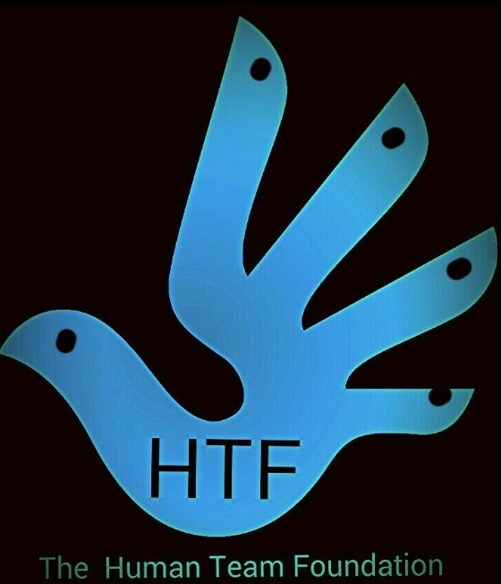

The Human Team Foundation essentially helps anyone who is in need, including elderly people, stray animals, and orphans.   
 They also assist those   
in need and exhibit compassion and love,   
for all living things, regardless of their caste, sex, or creed.  
 It aims at providing/spreading happiness to youngsters with special needs   
or those battling alone in the world.  
 Additionally, they have a well-reputed past and they also contributed to helping during the pandemic by giving food packages and medicines to those in need.

**Project Objectives:**

To help the Human Team Foundation by providing support to the old aged people with small activities, and technical as well as emotional support.

**Project Activities:**

1. Help the old people to visit their banks.
2. Interact, Serve food and do similar small activities with the Old age people.
3. Helping the organisation with technical support.
4. Maintaining the NGO’s database and explaining the future implementation to them.
5. Developing and maintaining their website.

**Time duration**:

We’re aiming for 60+ hours in 2 months   
(Including the meetings with the Human Team Foundation Representatives)

**Skills and Experience Required:**

1. Good communication skills
2. Technical Skills (Database, Web Dev.)
3. Empathy and understanding.
4. Social Responsibility.

**Methodology**

We had the vision to work at an NGO which would help us by exposing us to every form of social work, which would help us to understand each individual’s comfortability with different types of social work. Human Team Foundation caught our attention since it is a big NGO that provides almost every form of social help and recruits volunteers for the same from time to time.

We approached them and showcased our interest in their organisation, Our enthusiasm and interest lit up a spark in their hearts and they accepted at the very instant.

Now we are working under their organisation and looking forward to learning, adapting, and forming a new vision for society!

We have discussed that due to our regular college and college workload, we would only be able to mostly visit the NGO on Sundays or on some Saturdays.

After talking it over with the organisational representative, he said that it’d be fine if we come according to our convenience.

**\*\*\*\*\***